
NEIGHBOURHOOD,
PLACE AND POSTCODE



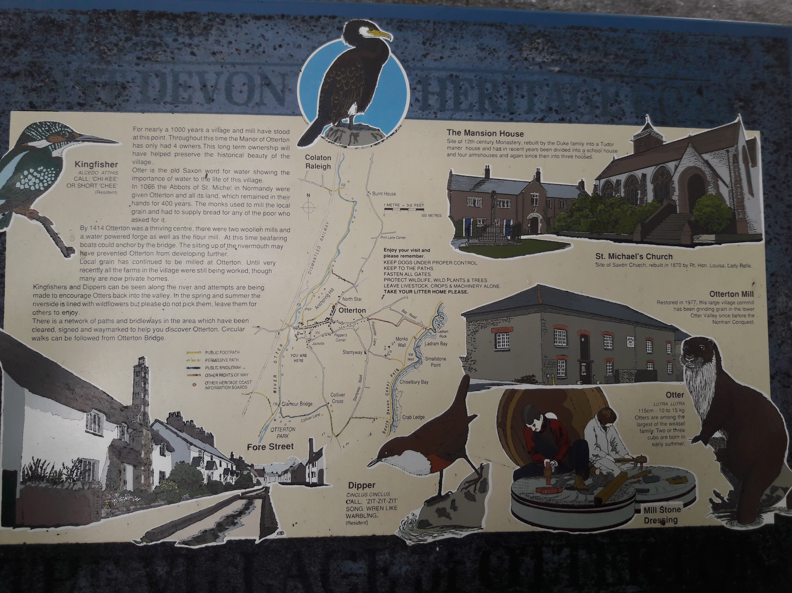(Start your trail text here)

